**-> Analysis of all the visualizations with respect to how it is helping you find the Key Performance Indicators and the causes of various problems identified.**

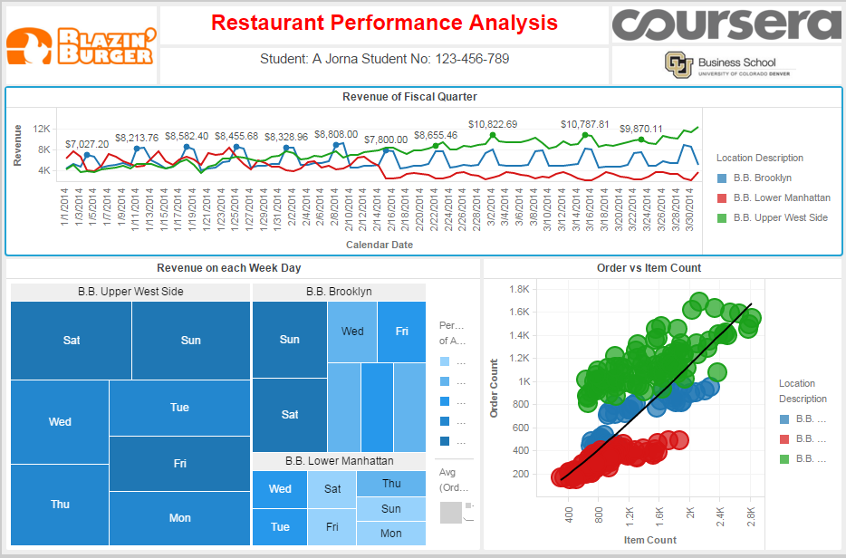

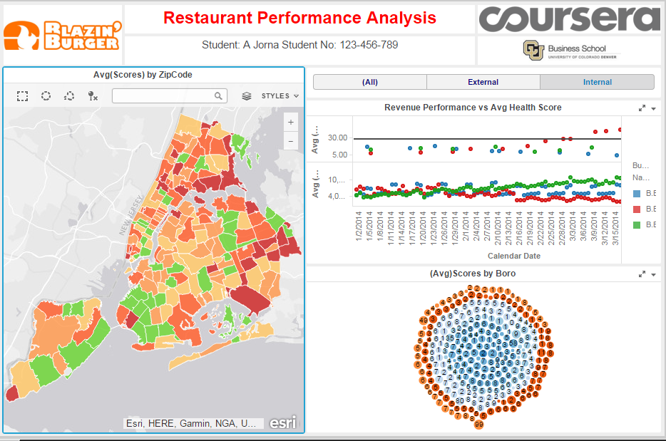

The line chart helps to know about the growth and fall during given fiscal quarter at the three different locations. The **Revenue** increases in the **Upper West Side** and decreases in the **Lower Manhattan.** The heat map shows that the **Revenue is at peak on the weekends**. The reason behind this is obviously, the holiday that everyone celebrates outside with their family and friends. In the bubble chart, we can see that there is a **large difference between item count and order count** in the location Lower Manhattan. The reason behind this is the fall in revenue at this location.

In the second worksheet, we are able to analyze performance with the help of the Health Inspection Score, where you can see for instance how the poor average health inspection score in Lower Manhattan affected average revenue in a negative way.

**-> What more could you have done other than what is included in the exercise to achieve better analysis of both the datasets?**

I would have done the Avg. Score by Boro visualization able to highlight the Map in Sheet 2. A barchart can show more clearly the correlation between health-grade and/or violations, and revenue. This visualization would help in observing the effect of health score on the revenue in other particular ways.